GeoBikeLLM: LLM-Powered Bike Route Planning with Air Quality and Vegetation-Aware Geospatial Intelligence

Menatalla Haggag∗, Lubana Al Rayes ∗, Esraa Alhamid ∗, Sara Alshamsi4∗, Isam Al Jawarneh∗
∗Computer Science Department, University of Sharjah, Sharjah, UAE
{U23103328, U23103394, U24105438, U24102808, ijawarneh}@sharjah.ac.ae

Abstract—
Keywords—Geospatial , LLM , Air Quality , NDVI, GIS

Introduction

Related Work
Recent advancements in GeoAI and LLM research have enabled natural language interfaces for querying and interpreting geospatial data. Studies have explored both LLM-augmented spatial querying and multimodal systems integrating maps, satellite imagery, and text for environmental reasoning. This section reviews existing approaches and highlights the gap that our proposed GeoBikeLLM system aims to fill.

LLM-Augmented Geospatial Understanding and Querying
Recent research has focused on enhancing geospatial data accessibility through natural language interfaces powered by large language models (LLMs). Systems like ChatGeoAI by Mansourian and Oucheikh [1] and the SQL-generation framework by Jiang and Yang [2] enable users to perform GIS tasks or query spatial databases using natural language. ChatGeoAI employs LLaMA-2 to convert queries into executable PyQGIS scripts, while Jiang and Yang use ChatGPT to generate PostGIS-compatible SQL. Text-to-OverpassQL by Staniek et al. [3] further advances this by translating natural language into OverpassQL queries for OpenStreetMap, democratizing access to structured geodata.
Other studies investigate how LLMs can interpret or extract geographic knowledge. GeoQAMap by Feng et al. [4] utilizes GPT-3.5 and Wikidata to answer geographic questions and visualize answers on maps. GeoAgent by Huang et al. [5] focuses on address standardization using ChatGLM-6B, showing how LLMs can resolve ambiguous and incomplete geospatial texts. Meanwhile, Bhandari et al. [6] evaluate whether large language models are geospatially knowledgeable, revealing that while some geospatial knowledge exists in pretrained models, it is often imprecise.
To overcome these limitations, domain-adapted models have emerged. BB-GeoGPT by Zhang et al. [7] is a fine-tuned LLaMA-2 model trained on GIS texts and Q&A pairs, outperforming general LLMs in spatial queries. Similarly, GeoLLM by Shah et al. [8] boosts geospatial prediction accuracy by embedding map-based contextual data into prompts. These efforts establish the foundation for natural language interaction with spatial systems but stop short of performing complex geospatial planning or optimization.

Multimodal Geospatial Intelligence for Environmental and Spatial Planning
Advancements in GeoAI have expanded to multimodal systems integrating LLMs with visual and structured geospatial data. OmniGeo by Yuan et al. [9] exemplifies this trend by combining satellite imagery, map layers, and text data, enabling LLMs to perform diverse tasks such as land use classification and environmental forecasting. Geode by Wu et al. [10] and GTChain by Zhang et al. [11] extend LLMs into autonomous agents, coordinating APIs, GIS tools, and real-time databases to solve spatial tasks.
These systems demonstrate the potential of LLMs in spatial reasoning, data retrieval, and geospatial tool orchestration. Geode performs zero-shot geospatial Q&A with explicit reasoning and live data, while GTChain trains LLMs to generate tool-use chains for complex tasks in simulated GIS environments. The autonomous GIS agent by Ning et al. [12] also showcases how LLMs can be used to dynamically retrieve data across diverse spatial datasets, enhancing spatial decision-making workflows.
Despite these advancements, existing solutions lack targeted support for personalized route planning or environmental criteria integration. None of the reviewed systems directly tackle bicycle routing that adapts to vegetation or pollution levels. Our proposed GeoBikeLLM addresses this gap by combining LLMs with geospatial intelligence to deliver environment-aware, health-optimized bike route planning.

Methodology

Datasets
To support environment-aware and health-optimized route planning in Chicago, this study integrates three geospatial datasets: air quality measurements, vegetation indices, and bike infrastructure.

Air Quality Data: The air quality data is sourced from the Chicago Eclipse Air Quality Dataset, which contains sensor-based measurements of particulate matter (PM2.5) across various locations in the city. Each record includes the geographic coordinates of the sensor, the timestamp of the reading, and the corresponding PM2.5 concentration. These data help evaluate local pollution levels along potential bike routes.

NDVI Dataset: The NDVI dataset provides spatial measurements of vegetation health across Chicago. Each entry corresponds to a specific location defined by geographic coordinates and includes a ‘grid_code’ representing the NDVI value. Higher NDVI scores indicate greener areas, making this dataset essential for assessing environmental quality and greenery exposure during routing.

Bicycle Network Dataset: This dataset captures the spatial structure of the bicycle infrastructure in Chicago, derived from OpenStreetMap (OSM). It includes details on individual bike path segments, such as start and end coordinates, segment lengths, and geometry data. The dataset supports the construction of a navigable network for route computation between user-defined locations.
These datasets collectively enable the integration of air quality and environmental context into the spatial decision-making process for bicycle routing.

Dataset Visualization and Exploration
To better understand the spatial distribution of air pollution and vegetation in Chicago, we performed exploratory visualizations using Folium and Python libraries. PM2.5 sensor data was plotted to identify high-pollution zones, while NDVI values were visualized to detect greener regions.

Air Quality Visualization
To visually explore the air quality dataset, a heatmap was generated using the PM2.5 readings across various geographic locations in Chicago. The map shown in Figure 1 represents the normalized PM2.5 values, with areas of darker intensity indicating higher pollution concentrations. The heatmap was created by aggregating data from 19 CSV files hosted on GitHub, each containing latitude, longitude, and PM2.5 values for different parts of the city. After cleaning and normalizing the data using Min-Max scaling, each point was plotted using Folium’s HeatMap plugin. The visualization reveals several hotspots of elevated pollution, particularly along dense urban corridors and industrial zones.
This spatial representation helps identify areas that may require further attention or intervention for environmental and public health planning.
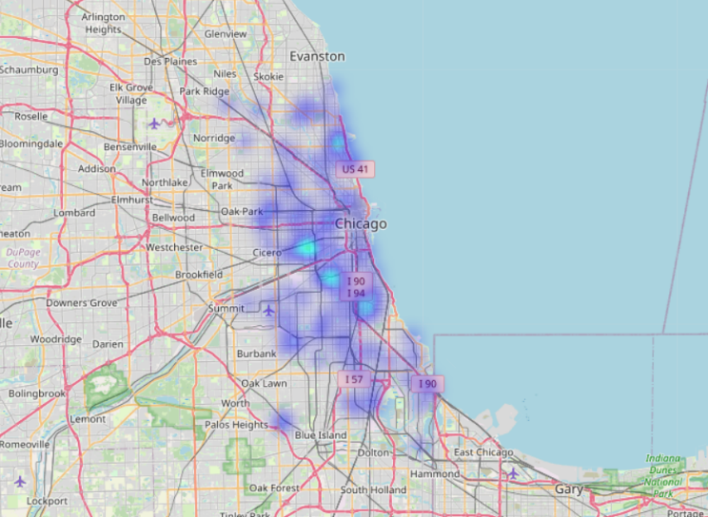

Path Selection Module
The core of the route planning logic involves constructing a weighted undirected graph from the Chicago bike lane dataset. Each edge represents a bike segment with an associated length, while nodes correspond to geospatial coordinates. To account for environmental quality, air pollution data (PM2.5) and vegetation density (NDVI) are spatially matched to each segment using nearest-neighbor querying via KD-Trees. The cost of each edge is computed as shown in (1), where α and β control the influence of PM2.5 and NDVI, respectively.
Cost = length×(1+α⋅PM2.5−β⋅NDVI) 
where α and β are tunable weights for penalizing poor air quality and rewarding greenery, respectively.
To determine optimal bike paths, the system connects the user-specified origin and destination to the nearest nodes in the network via virtual edges. Then, using Yen’s algorithm, the top-k shortest paths are extracted based on the computed cost. A penalty is applied to reused edges across iterations to encourage route diversity. For each path, average PM2.5 and NDVI values are computed, and the route with the lowest pollution and highest greenery score is selected as the recommended path. This environmentally informed selection approach balances travel distance with health and ecological considerations, enabling context-aware route planning.

LLM Integration
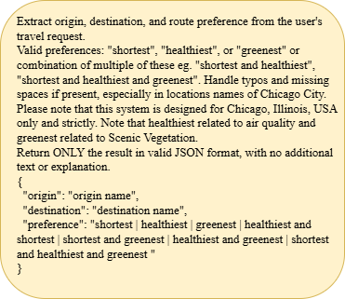

In the proposed routing system, two LLMs are integrated using the Groq API to enhance the NLP and explanation capabilities of the application.

Query Interpretation using LLaMA 3.1 8B Instant: This model is used in the extract_trip_info(prompt) function. It parses free-form user prompts to extract three structured elements: the trip's origin, the destination, and the routing preference (e.g., shortest, greenest, or healthiest). The system prompt explicitly instructs the model to focus on the Chicago area and to correct for common user input issues such as misspellings, missing spaces, or informal phrasing. This design ensures that users can interact with the system using natural language without adhering to strict formatting, improving accessibility and usability. As shown in Figure num (caption: Structured system prompt used to extract origin, destination, and routing preference from natural language input.), the prompt used for the LLM clearly defines the expected output format and constraints tailored to Chicago-specific queries.

LLaMA 3.3 70B Versatile for Explanation Generation: This larger model is employed to generate concise and informative textual explanations for the recommended route. It was chosen for its advanced reasoning capabilities and high-quality language generation, which are essential for summarizing spatial decisions involving air quality, greenness, and distance. By presenting these factors in a user-friendly format, the model enhances the system's interpretability and transparency. As shown in Figure num (caption: Prompt used to instruct the LLM to generate concise, user-friendly explanations for the selected route.), the prompt provides a structured template that guides the LLM in producing 2–3 clear sentences explaining how environmental criteria influenced the recommended route.

Prompt Engineering: This part

LLM Evaluation: To evaluate the effectiveness of the LLM in accurately extracting structured information from natural language prompts, we conducted a controlled test using 35 user-generated inputs. Each prompt reflected realistic and diverse travel requests, including typographical errors, informal phrasing, and mixed formatting. At the time of testing, the system was configured to extract both the origin and destination, as well as routing preferences (e.g., healthiest, shortest, greenest). The extracted values were compared against the manually annotated ground truth for each prompt. Accuracy was computed based on the correct identification of both location entities and preference tags. This evaluation helped validate the reliability of the LLM in parsing location-based instructions under noisy real-world conditions and informed our later decision to shift preference input from text to user-adjustable sliders for greater precision and control.

The integration of LLMs in this project enhances accessibility by enabling natural language interaction with complex geospatial computations. The system can interpret a wide range of user inputs, including informal phrasing, typographical errors, inconsistent formatting, and loosely defined place names. This eliminates the need for rigid query structures or rule-based parsing, allowing users to communicate using everyday language. In addition to interpreting queries, the LLMs generate clear and concise explanations for routing decisions, improving transparency and user trust.

Overall System
The GeoBikeLLM system enables natural language-based bike route planning within Chicago, Illinois, by integrating environmental and spatial data to recommend optimized cycling paths. Users interact with the system by entering a prompt such as "I want to go from Melrose Park to Hyde Park." The system employs LLM to extract only the origin and destination from the prompt, accounting for informal phrasing, typos, and spacing issues in location names. The system prompt used to guide this extraction is shown in Figure num (caption: System prompt provided to the LLM for extracting origin and destination.), which explicitly restricts the task to valid JSON output and enforces geographic constraints within Chicago.
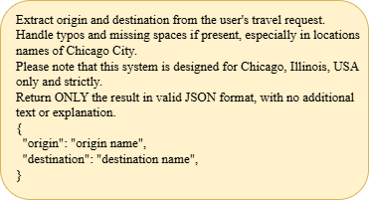
To offer users greater control over route optimization, the system provides two adjustable sliders in the user interface: one for Air Quality Penalty and another for Greenness Reward. These sliders eliminate the need to express routing preferences within the prompt itself. The air quality slider (α) penalizes routes with higher PM2.5 levels, while the greenness slider (β) favors paths with higher Normalized Difference Vegetation Index (NDVI) values.
Once the origin and destination are identified, the system constructs a geospatial graph of Chicago’s bike network. Each edge in the graph is dynamically weighted based on nearby air quality and vegetation data obtained from environmental sensors. Route computation is carried out using an adapted Yen’s K-Shortest Paths algorithm, which generates multiple path options while incorporating the user-defined environmental weights.
Finally, the system displays an interactive route map, computes the estimated time of arrival (ETA), and uses a second LLM query to generate a concise natural language explanation of the recommended route. This explanation reflects how the selected route aligns with the user’s environmental preferences.

Results

Best Path Selection

In the results of the first part of the project, the system found the best biking path from Melrose Park to Hyde Park by looking at both air quality and green areas. This best path is shown in light green on the map. It is about 37.36 kilometers long, with low air pollution (PM2.5 = 6.42) and good greenery (NDVI = 0.10). The system chose this route because it is the cleanest and greenest among the options. It used Yen’s K-shortest paths algorithm, which finds several different route options between the two locations, and then selects the one with the lowest average air pollution and the highest green coverage based on data from PM2.5 sensors and NDVI readings. The other paths are also shown on the map in different colors; the light green path clearly marks the healthiest and most eco-friendly route.

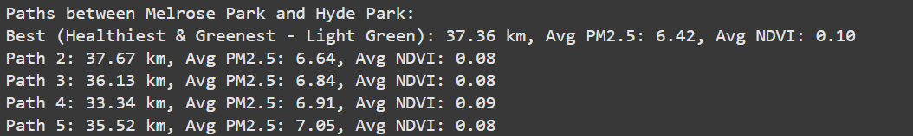
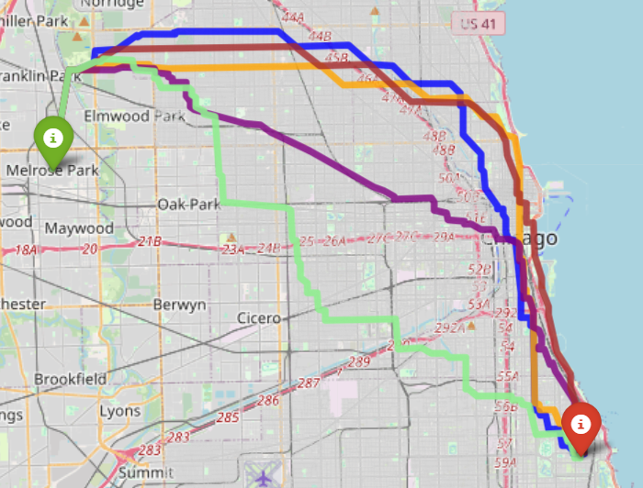

LLM Results

Query Interpretation using LLaMA 3.1 8B Instant: To assess the performance of the LLaMA 3.1 8B Instant model in query interpretation, we evaluated its ability to extract structured information from 35 user prompts. These prompts were designed to reflect diverse natural language variations, including typos, spacing issues, and informal phrasing. Out of the 35 prompts, the model correctly identified both the origin and destination in 33 cases, achieving a location extraction accuracy of 94.3%. Similarly, the model correctly extracted the user’s routing preference (e.g., healthiest, shortest, greenest) in 33 out of 35 cases, also yielding a preference extraction accuracy of 94.3%.These results demonstrate the model’s robustness in understanding noisy and informal user inputs. However, minor inconsistencies were observed in cases involving ambiguous phrasing or rare place names, which supports the decision to shift preference input to sliders in the final system design.

Figures and Tables

Acknowledgment (Heading 5)
Edit acknowledgement

References
- Mansourian, A. & Oucheikh, A. (2024). ChatGeoAI: Enabling Geospatial Analysis for Public through Natural Language, with Large Language Models. ISPRS International Journal of Geo-Information.
- Jiang, Y. & Yang, C. (2024). Is ChatGPT a Good Geospatial Data Analyst? Exploring the Integration of Natural Language into Structured Query Language within a Spatial Database. ISPRS International Journal of Geo-Information.
- Staniek, M., et al. (2024). Text-to-OverpassQL: A Natural Language Interface for Complex Geodata Querying of OpenStreetMap. Transactions of the Association for Computational Linguistics.
- Feng, Z., et al. (2023). GeoQAMap: Geographic Question Answering with Maps Leveraging LLM and Open Knowledge Base. GIScience 2023, Leibniz International Proceedings in Informatics.
- Huang, W., et al. (2024). GeoAgent: To Empower LLMs using Geospatial Tools for Address Standardization. Findings of ACL 2024.
- Bhandari, S., et al. (2023). Are Large Language Models Geospatially Knowledgeable?. ACM SIGSPATIAL 2023.
- Zhang, Z., et al. (2024a). BB-GeoGPT: A Framework for Learning a Large Language Model for Geographic Information Science. Information Processing & Management.
- Shah, R., et al. (2024). GeoLLM: Extracting Geospatial Knowledge from Large Language Models. ICLR 2024 Conference Track.
- Yuan, Q., et al. (2025). OmniGeo: Towards a Multimodal Large Language Models for Geospatial Artificial Intelligence. arXiv preprint.
- Wu, K., et al. (2024). Geode: A Zero-shot Geospatial Question-Answering Agent with Explicit Reasoning and Precise Spatio-Temporal Retrieval. arXiv preprint.
- Zhang, Z., et al. (2025b). Geospatial Large Language Model Trained with a Simulated Environment for Generating Tool-Use Chains Autonomously. Future Generation Computer Systems.
- Ning, Y., et al. (2025). An Autonomous GIS Agent Framework for Geospatial Data Retrieval. International Journal of Digital Earth.

